**Name: SHIVAM BISWAS**

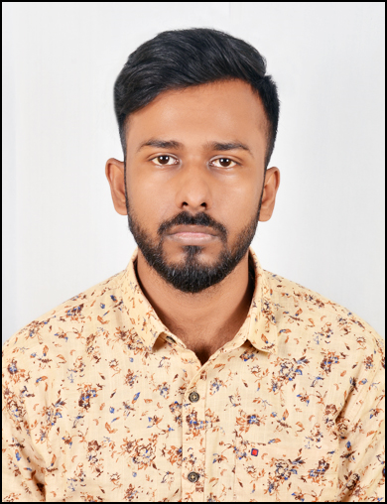

**Address: Block Chowk, Ormanjhi, Ranchi-835219, Jharkhand**

**Mobile no.: 7439334856**

**Email: shivambiswas172@gmail.com**

**CAREER OBJECTIVE**

To secure a position in your company which could help me to develop new skills and deliver my potential of financial analysis and strategic performance of the new approach towards the growth of the company.

**PROFESSIONAL QUALIFICATION**

Pursing Post Graduate (MBA) 2022 – 2024 from Usha Martin University, Ranchi, Jharkhand with specialization in Marketing and Finance.

**ACADEMIC QUALIFICATION**

|  |  |  |  |  |
| --- | --- | --- | --- | --- |
| Degree | College/School | University/Board | Passing Year | Percentage |
| Graduation | University of Calcutta | University of Calcutta | 2022 | 59% |
| Intermediate | Manan Vidya, Ranchi | CBSE | 2019 | 66.25% |
| Matriculation | Abbot Shishu Hall, Hooghly | ICSE | 2017 | 73.6% |

**COMPUTER PROFICIENCY**

* Basic knowledge about MS Office (Word, Excel, Power Point).

**SUMMER INTERNSHIP**

* Organization : Outlook Publishing Pvt. Ltd.
* Title : Marketing Intern
* Duration : 2nd August 2023 to 3rd October 2023
* Roles & Responsibilities : Customer relationship management using Knowledge

Jockey.

Marketing and Sales Project.

Marketing Research and Strategy Making.

Marketing Analytics.

Digital Marketing.

**EXTRA-CURRICULAR ACTIVITIES**

* Participated in the Global Entrepreneurship Summit 2023 organized by Entrepreneurship Cell, IIT Kharagpur from 3rd to 5th February, 2023

**STRENGTHS**

* Quick learner
* Hardworking
* Fast decision maker
* Effective Time manager
* Excellent Communication skills

**HOBBIES**

* Reading books
* Travelling
* Photography

**PERSONAL PROFILE**

* Language Known : English, Hindi, Bengali
* Date of Birth : 06th March 2001
* Gender : Male
* Father : Subrat Chandra Biswas
* Mother : Ranu Biswas
* Nationality : Indian
* Marital Status : Unmarried
* Permanent address : Block Chowk, Ormanjhi, Ranchi-835219, Jharkhand

**DECLARATION:**

I do hereby declare that the above stated information is true to the best of my knowledge and belief.