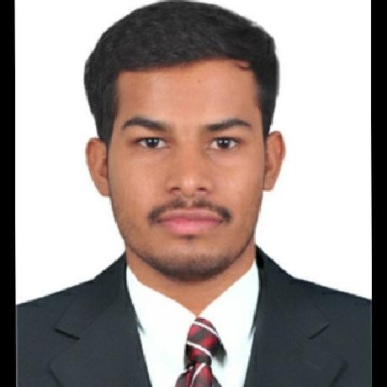shivakumar

[shivakumarkolle880@gmail.com](mailto:shivakumarkolle880@gmail.com) | 9553087615 | Nagarkurnool, Telangana

# Career Summary

Highly determined food processing and business management graduate with excellent technical and analytical skills. Seeking a position ina n organization to utilise my managerial and team building skills and to work towards the organisation's goals

# Educational Background

|  |  |  |  |  |
| --- | --- | --- | --- | --- |
| **Year** | **Qualiﬁcation** | **Institute** | **University** | **Marks** |
| 2023 | Food Processing Business Management | Indian Institute of Plantation Management | AICTE | Pursuing |
| 2021 | Graduation (Bachelor of Science in Agriculture) | Apollo Institute of Technology and Research, Hyderabad, Telangana | Singhania University | 70 % |
| 2017 | Class XII (BIPC) | Scholars Junior College, Wanaparthy, Telangana | Intermediate Board Of Education, Telangana | 63 % |
| 2015 | Class X (General) | Z.P.H.S, Peddakothapally, Telangana | Board Of Secondary Education,Telangana | 80 % |

**Internships**

Collect and sorting the Customer data according to Region wise. Applying The Scheme Related To Poultry Mon.

Interaction with the existing clients and maintaining the customer relationship Onboarding new customers

Developing product marketing strategies

Understanding the current trends in the market and developing pricing model

A Study on Business Development and Marketing Strategies at PoultryMon MLIT.

**MAY2022-AUG2022**

**Summer Internship**

**MLIT-Sol Pvt Ltd. - Hyderabad, Telangana, T-hub2.o**

Samhitha Crop Care Clinics

Interacted with the farmer community and consulted them about the problems they are facing in farming and then providing them with solutions for disease Control and plant health management.

To collect the each plant diseases data into the mobile applications.

**6 Months**

**Field Work**

**AELP Training - Nalgonda, Telangana**

**Academic Projects**

**Live Project on Priya Pickles in Hyderabad Study on Promotional strategies of mcdonalds**

**Live project Consumer Attitude towatds Britannia biscuits, Bengaluru**

**Certiﬁcates**

* Business Analytics by Intellipaat in association with International Institute of Business Analysis (IIBA) and International Business Machines (IBM)

2023

**Other Information**

|  |  |
| --- | --- |
| **Technical Skills** | Google SpreadSheet , Advance Excel , SQL , Tableau , Microsoft Power Bi , Business analyst , Python. |
| **Soft Skills** | Problem Solving , Self Conﬁdence , Team player , Time management. , Creativity |
| **Interests** | Dancing. , Cooking |
| **Spoken Languages** | Telugu. , Hindi , English |
| **Date of Birth** | 05/04/1999 |
| **Social** | shivakumar-kolle-802737217 |