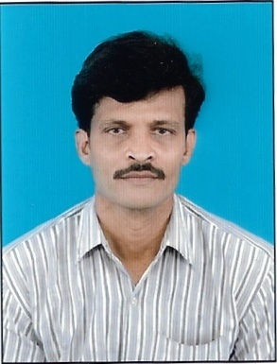

**CURRICULUM VITAE**

PERSONAL INFORMATION:-

Name : GautamChowhdury

Date of Birth : 13.05.1976

Name Of Father : Late.Paresh Chandra Chowdhury

**Contact Telephone Numbers:**

* 9674976486 (Whatsapp No)
* 8584045956

Permanent Residential Address: 66/C, Firingidanga Road,

P.O: Mallickpara, Serampore,

Dist: Hooghly,

Pin Code-712203

(West Bengal)

EXTRA CURICULLAR ACTIVITIES:

Participated in Inter Collge Cricket Competion on 1996 under

University Of Calcutta.

**ACADEMIC QUALIFICATION:**

|  |  |  |  |
| --- | --- | --- | --- |
| Name Of Examination | Board/University | Passed Year | Percentage Of Marks |
| 10th StandardMadhyamik | W.B.S.E | 1992 | 39.55% |
| Higher Secondary | W.B.C.H.S.E | 1994 | 48.8% |
| B.COM(Two Year Pass Course) | University Of Calcutta | 1999 | 35.6% |

**TECHICAL LITERACY QUALIFICATION**:

|  |  |  |  |
| --- | --- | --- | --- |
| Name Of Course | Institute/College | Passed Year | Grade |
| Certificate in Financial Accounting | Serampore Youth Training Centre | 2001 | A |

**PROFESSIONAL LITERACY QUALIFICATION**:

|  |  |  |  |
| --- | --- | --- | --- |
| Name Of Course | Institute/College | Passed Year | Grade |
| Professional Certificate Course in Accounting & Taxation | Bengal Tax Counsel, Kolkata | 2007 to 2009 | A |

**PROFESSIONAL JOB (Worked) EXPRIENCES DETAILS(LAST):**

|  |  |  |  |
| --- | --- | --- | --- |
| Name Of Job | Organization | Type Of Organization | Period |
| Computer Operator | M/s Nafis Tanning Industries | Dealer of FMCG | 2003-2006 |
| Floor Supervisors | Rajprotim Agency | C&F Agent | 2009-2010 |
| Transport Executive | Shree Vasu Logistic Ltd (A Unit Bengal Logistic Ltd) | C&F Agent Cum Logistic Service | 2017-2020 December’20 |
| Computer Operator | Sky Net Cyber Cafe | Cyber Café | From January’21 to March’21 |
| Office Assistant | A.K.Enterprise a Sister Concern of M/S Amalgamated Scientific Suppliers Pvt Ltd | C&F Agent of BIOTECH Medicine | From 01 Nov’21 to 08.07.2022 till Now |

Note:- I belong Railway background family member.

***Declaration:-***

I hereby declared that all the information here true and correct from best of my Knowledge.

**Signature of the Applicant**

Place: Serampore

Date:10th October,2022