CURRICULUM VITAE

Personal Information
Name: | Swagata Sinha
Address: | 144, Sri Ram Dhang Road, Salkia, Howrah - 711106  West Bengal, INDIA
Date of Birth: | 5th March 1998
Mobile: | 6375268401
Email: | swagatasinhabanerjee@gmail.com

Educational Qualification
Name of the examination | Institute | Percentage | Year of passing
Post graduate Diploma in Human Resource Development & Labour Welfare | State Labour Institute | Result Awaited | 2022
Bachelor of Commerce  (Calcutta University) | Acharya Girish Chandra Bose College Formerly Bangabashi College of Commerce | 56.44 | 2018
Higher Secondary (XII) | Salkia Kedarnath Babulal Rajgoria Girls Hish School | 81 | 2015
Madhyamik | Salkia Kedarnath Babulal Rajgoria Girls Hish School | 61.29 | 2013

Technical Knowledge:
- Extensive knowledge of internet and Computer.
- MS Office, Access, Excel, Word, Power Point
- Tally ERP.9

Other Personal Details
Mother’s Name | Mrs. Mita Sinha
Father’s Name | Mr. Swapan Kumar Sinha
Nationality | Indian
Gender | Female
Religion | Hindu
Marital Status | Married
Languages Known | English, Bengali and Hindi

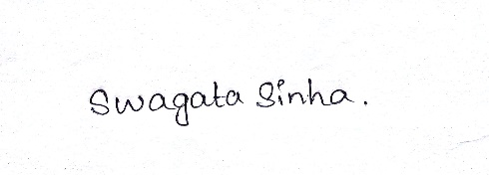
I, hereby, declare that all the particulars given above by me is true, complete and correct to the best of my knowledge and belief.

Swagata Sinha

