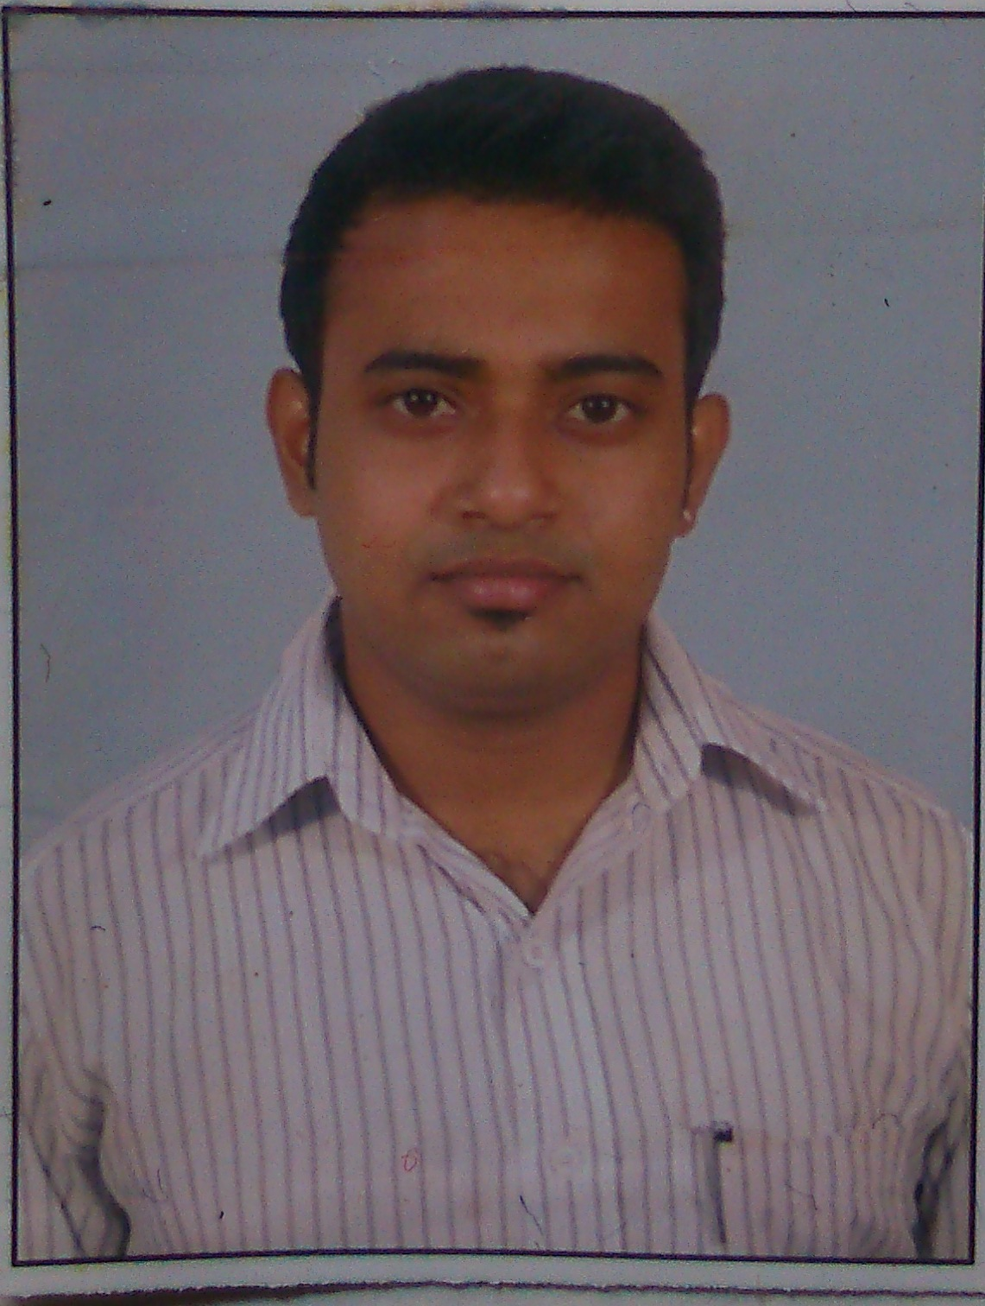
ARNAB DAS

14, GM Road, Baghajatin,
Kolkata  700086
Ph: +91 8420297369;
Email: dasarnab72@gmail.com

Objective

Keen to have a challenging and performance oriented career with an organization of distinction which recognizes my true potential and provides me sufficient avenues for professional growth in the field of Sales & Marketing .

STRENGTHS

Backed by strong academic credentials: MBA; targeting assignments in the field of Information Technology, marketing management, operation management, possess zeal to make a mark in the Industry and to further companys objectives and goals within timelines

Self motivated, hard working and goal-oriented with a high degree of flexibility, creativity, resourcefulness, commitment and optimism.
.
WORK EXPERIENCE

(Year 2010 November-2011 May)- Worked in HCL Info system in sales(Laptop division), as a product consultant.
Job Profile : I was in the profile of Inshop Demonstrator handling HCL laptop as the productline.
Achievements : 1. Achieved targets all through except one month.
2. In the month of January I did all time highest sales out of 40 laptops in a month.
3. I handled home users and even some SME/ SMB customers

(Year 2011 June-2012-JULY) Worked in Samsung India pvt Ltd in sales(Laptop division), as a product consultant
Job Profile : I was in the profile of Inshop Demonstrator handling Samsung laptop as the product line.
Achievements : 1. Achieved targets all through.
2. Highest sales out in a month was 80 laptops.
3. I handled home users and even some SME/ SMB customers

(Year 2012 July- 2014 September)- Working in SanDisk for Solution Digitas as a Retail sales officer.
Job Profile : As a Retail Sales Officer in Sandisk, my responsibility is to develop the business in retail distribution channel of Kolkata and also positioning our range of products in some major corporates.
Achievements :
- Cracked a deal with Samsung for gifting articles.
- Office Linc was also roped in.
- Developed the business of Kolkata from 5 lacs to 50 lacs through retail channels for high performance or high end skus.
- Achieved quarter targets.

(Year 2014 September-December 2015)-Worked in Targus India Pvt. Ltd for ChannelPlay.
As a Relationship Manager-Sales .
Achievements : 1. Developing the channel distribution of Targus India in Kolkata and South Bengal.
- In Targus India, Ive revived my relationship with different corporates like, Ushacomm, Kesoram Group, Acclaris , etc. started quoting my products. Closed big orders from PWC, Mjunction(Tata Group) & regular orders from Birla Tyres, Ushacomm, Acclaris, IIFT etc.
- Training programs organized & given in corporates.
- Co-ordination with national distributors, & maintaining equilibrium between the distributors & Channel partners.
(Year 2016 8th Feb July 2016)- Worked at Oppo Mobiles India PVT ltd as Team Leader.
Key responsibility-
- Developing the Modern Trade Channel Of TMS & produce sales from the desired outlets.
- Looking after the OSR & their sales on daily basis..
- Giving proper training to the OSR.
- Achieved monthly targets..

(Year 2016 September-11th to May'2018)-Worked at Honeywell Connection as Channel Sales Manager
Key Responsibility-
- Developing the channell of Telecom & It partner of Kolkata & WB market.
- Co-ordination with national distributor, & maintaining an equilibrium between the distributors & Channel partners.
- Developed the business of Kolkata from 0 to 10 lacs through retail channels in West Bengal in 6 months.
- Achieved Quarter Targets..

(Year 2018, 11th May18-June2019)- Working In Ambrane India PVT Ltd As Territory Sales Manager
West Bengal .
- Developing the channell of Telecom & Accessories partners of Kolkata & WB outstation market.
- Developed the business of Kolkata from 0 to 12 lacs/month through retail channels in West Bengal in 6 months.
- Achieved Quarter Targets in mostly every months..
Core Area- Kolkata Mainly, South 24, North 24, Berhampore(Murshidabad), Hooghly, Midnapore(East & West)

(Year 2019, 8th-July2019 to Feb'2021)- Worked at Conekt Gadget LLP (Celkon group, Hyderabad) as State Head.
Key Responsibility-
1. Developing the Telecom partners & Accessories Channel & some It partner of Kolkata & WB outstation market.
2. Developed the business of Kolkata from 0 to 18 lacs/month through retail channels in West Bengal in first 3 months.
3. Achieved Quarter Targets in mostly every months
Core Area- Kolkata Mainly, South 24, North 24, Berhampore(Murshidabad), Krishnanagar, Hooghly, Midnapore(East & West),

Year 2021- March'2021 to present- Working at Honeywell Connection for IT peripherals and Telecom Audio products, Looking after Distribution & Channel...
Area- West Bengal and Bihar location, Based in Kolkata..
1. Developing the Telecom partners & Accessories Channel & It partner of Kolkata & WB outstation market.
2. Developed the business of Kolkata from 0 to 15 lacs/month through retail channels in West Bengal within first 3 months.
3. Developed Bihar Patna market from 0 to 5 Lacs within 2 months of joining..

TECHNICAL SKILLS
Possess Knowledge of MS Office and general knowledge of using computer.

EDUCATIONAL CREDENTIALS
BCA - 2010
George College WBUT,67%

Class XII- 2007
Andrews High School, 52%

Class X -2005
Andrews High School, 52%
POST Graduation- MBA
Completed MBA from Sikkim Manipal University (2012-2014)- 74%

PROJECTS UNDERTAKEN
Title | Library Management System
Technology Used | JAVA

PERSONAL DOSSIER
Date of Birth: 23rd January 1988

EXTRA CURRICULAR ACTIVITIES
Played 2nd division cricket in 2007 & under 15 junior Bengal cricket in 2003.

HOBBIES
Playing and watching cricket , listening to music & chating with friends etc.

LANGUAGES KNOWN  1> ENGLISH - (Read, Write, Speak).
2> BENGALI - (Read, Write, Speak).
3> HINDI - (Speak Only).

( I hereby declare that the above informations are true to my knowledge and nothing has been concealed in it.)

Thanking You,
Date :- ARNAB DAS

